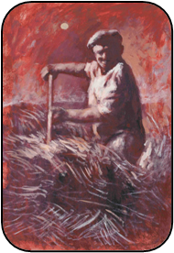
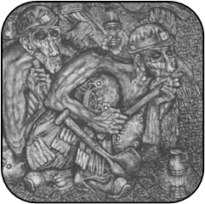
“Down the Pit” by Nicholas Evans
Features of pictures by Aneurin Jones
Features of pictures by Nicholas Evans
Features of both
pictures
“Lleuad Fedi” by
Aneurin Jones

